Security aspects of banknotes have to be reconsidered constantly and security features have to be improved to take effective measures against counterfeiters. We use a specialized form of the redundant Fast Wavelet Transform to gain and analyse the spectral components of banknote representations. By evaluating the high-frequency coefficients, we calculate appropriate features that contain characteristics of the selected patterns and allow for class discrimination. We found that use of statistical features is appropriate when analysing banknotes. The calculated features were fed into a classifier that successfully determined the authenticity of supplied banknotes.

**Intro**

One of the oldest security features, which is contained by nearly every denomination, is the raised surface. Special printing techniques add a unique structure to banknotes.

By use of appropriate analytical methods, one can use the Intaglio structures of circulating banknotes for authentication. One possibility is to apply a frequency transformation to the image of a banknote. This way we can split lower and higher frequencies, determine spectral components, and analyse them.

A suitable transform is the Wavelet Transform (WT). It has the ability to code discontinuities very well. When selecting the regions of interest (ROI), which contain the printing structures relevant for authentication, one has to mind the homogeneity of the textures. Heterogeneous textures can lead to deviations in feature calculation and therefore bias the results.

**Process of Data Collection**

**Image Digitization:** For our authentication research, we digitized three specimens by KBA-Giori S.A. that differ in the applied printing technique.

1. Genuine: These specimens resemble techniques used in common banknotes.

2. High-Quality Forgery: Specimens printed with an offset printing press. The printing plates were made by using original image files.

3. Low-Quality Forgery: Specimens printed with an offset printing press. The printing plates were made by using images that were produced by digitizing genuine specimens on a drum scanner.

Examples:

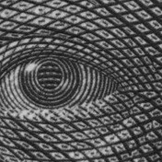 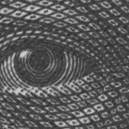 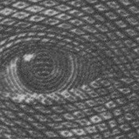

* + - 1. (b) (c)

**Fig. 1.** Different printing techniques for banknote reproduction: (a) Genuine, (b) High- Quality Forgery and (c) Low-Quality Forgery.

We used an industrial camera for digitization, which is usually used for print inspection. The 640x480 pixel images it produces are usually in grayscale, but due to the object lens and distance to the investigated object, we gained pictures with a resolution of about 660 dpi.

Our ROIs have an edge length of 400x400 pixels. In general, the saying "the bigger, the better" holds true, as long as the structure of the detail remains consistent. The reason for this is that bigger details are more durable when it comes to translations or changes of the motive.

To ensure that a banknote detail is appropriate for our authentication method, we have to test it for homogeneity. We test for homogeneity of the ROI by splitting the detail in 8 × 8 blocks Ri with

Ri (n, m) = x (n + b · i, m + b · i) (1)

and n ∈ N, m ∈ N, n ≤ b, m ≤ b, b: 8 | b, imax = N b = M b . b describes the edge length of the blocks and can be varied at will. After the splitting we calculate the mean gray value of each block:

R(i) = 1/b2 ∑ ∑ Ri (n,m) (2)

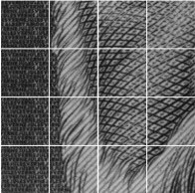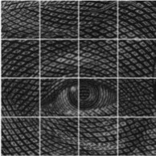

(a) (b)

**Fig. 2.** ROI, devided into blocks (left hand side) and resulting mean values (right hand side): ROI (a) is inhomogeneous and contains—in contrast to specimen detail (b)—more different printing structures. Such banknote details are inadequate for our implemented algorithms. On the contrary, detail (b) can be used for authentication.

We can detect the existence of different printing structures by evaluating the two mean value matrices. For this purpose, we calculate the standard deviation σ from the block means R and the value from the median filter. For discrimination of the images, we use a support vector machine (SVM) with a second order polynomial kernel.

**Wavelet Transform:** It is crucial for the recognition of local features that the signal transformation is shift invariant. This means that if a signal is shifted by ∆ samples, it will only lead to a shift of scaling or detail coefficients, but not to a change in their values. Essentially, this property guarantees that a scale diagram will not be affected by the zero point on a scale. However, when using the Fast Wavelet Transform (FWT), we lose this property because of its subsampling. Wavelet coefficients are highly dependent on signal shifts. This means that if we subsample when progressing to the next transformation scale, we risk losing important information about edges. Therefore, it is crucial to apply a signal transformation that is shift-invariant. We use shifting variant Wavelet Transform (SWT). SWTs provide shifted and otherwise identical wavelet coefficients for transforming two-dimensional banknote images into spectral descriptions. We apply two one-dimensional transformations. This is a valid approach because images are separable signals. To transform a two-dimensional signal x, we can employ the one-dimensional transformation algorithm on the image rows and columns alternately. This will result in a square matrix x1 with dimensions (2n × 2m).

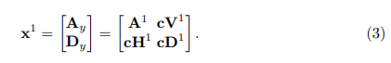

We divide the wavelet-transformed signal into four sub-images:

- The scaling coefficients A and vertical detail coefficients cV belong to Ay.

- The horizontal and diagonal detail coefficients (cH and cD) are comprised in Dy..

The detail matrices cV, cH, and cD describe the same structure of the wavelet-transformed signal of the image. To reduce computation time for evaluation, we combine the detail coefficients to the detail matrix

cG = (cV + cH + cD) · α (4)

with α being a scale factor.

Daubechies wavelets with two vanishing moments (db 2 wavelet) was used for better results. These wavelets are well suited for spectral analysis of fine Intaglio structures because of their compact support. Due to the scaling coefficients of the db 2 filter, low-pass filtering of continuous signals can lead to negative values [6]. In our multiresolution analysis, we make use of this effect that amplifies edges. Therefore, it improves our capability to distinguish between structures of different printing techniques.

**Feature Extraction:** We found that calculation of statistical features of wavelet coefficients is advantageous. By calculating descriptive measures on standardized histograms Hn(p) we are able to draw global conclusions on the image structure. We retrieve the following statistical features for further analysis of the wavelet coefficients: Variance σ 2 depicts the amplitude distribution of the wavelet coefficients around the histogram center. Skewness E describes the symmetry of the distribution around the center. Excess C tells the deviation relative to the Gaussian distribution.